SAN FRANCISCO INFO GRAPHIC
Name
Institution
Date
Info graphic on San Francisco
San Francisco is a county in the United States of America. Here is a brief info graphic about the county.
San Francisco is the happiest city in not only America but also in the world (Hannah 2017). From her research, Hannah shared experiences of her and other different persons having spent good time in the city. Her argument was that the city could never stay devastated for a long time.
Recently, a global perceptions organization conducted a survey in the county and it was ranked 7th among the happiest cities of the world. The survey also found the city to be the only happiest in the United States of America.
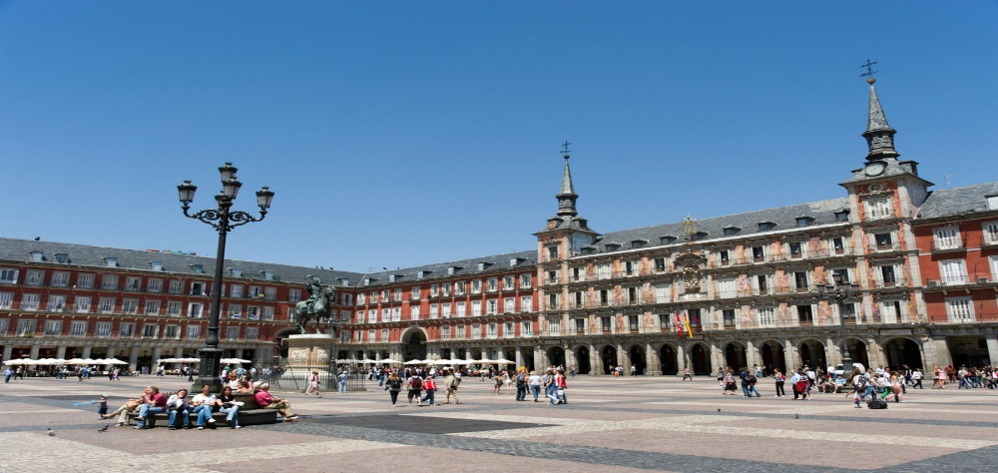
This is not an imposition argument, research engaged qualitative and quantitative data where possible to arrive at the inferences made. For instance, the GFK Custom Research Organization made calculations of the happiness implied. Happiness was ranked based on a number of attached factors. These were; the number of attractions outdoor, cultural areas and sites, shopping centres, and amusement opportunities that were captivating.
Major tourist attractions in the United States are in the county. For instance the Golden Gate Bridge opened in 1937. It is a very lucrative facility for America at large but it is situated at San Francisco. It has been used in major photography to trend the entire America. Its two towers stand up at 746 feet and the land mark spans for like 1.7 miles. In peak seasons, it always crowded as people from all over the universe visit the iconic structure.
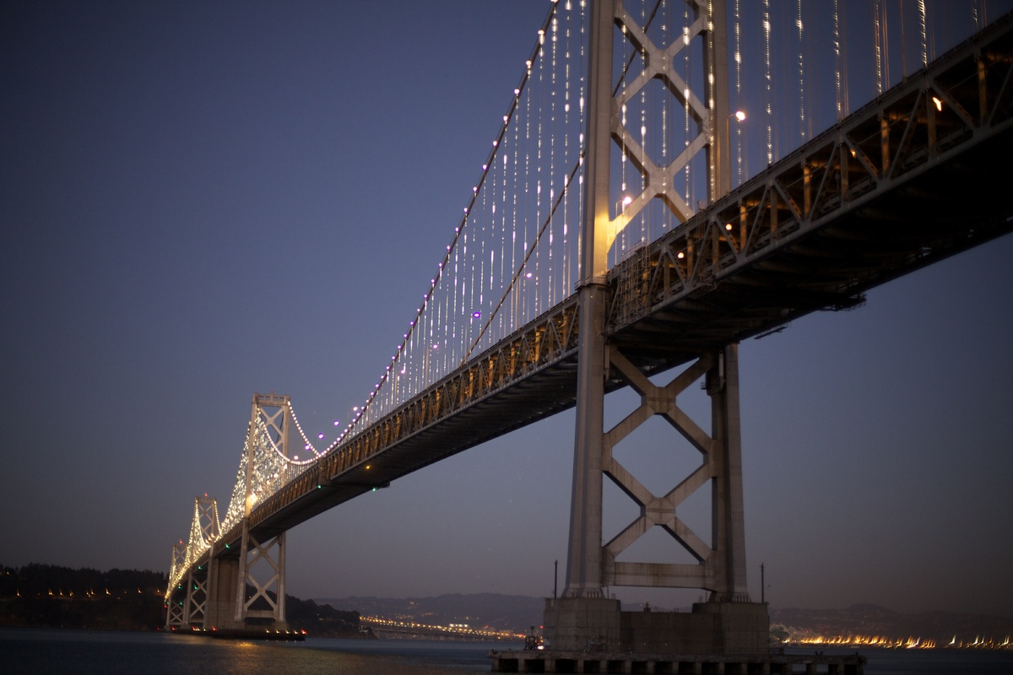
Figure: Golden Gate Bridge, San Fran. Source (Pinterest).
The Coit Tower or Telegraph Hill built in 1933has a height of 210 feet and on a foothill of 284 feet. Murals line the base of the structure that were painted during the great depression to symbolize Californians in 1934. It is very pretty with parrots’ homage at a close. A lot more.
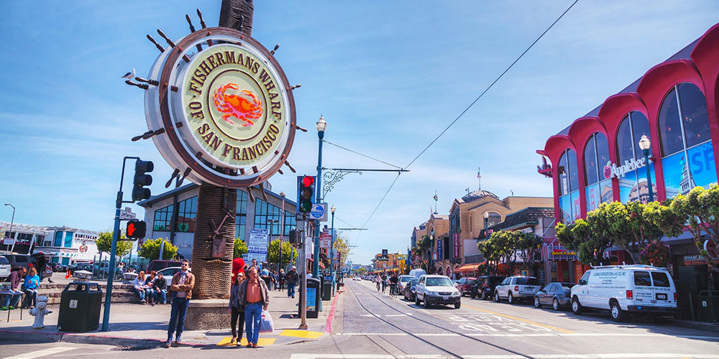

References
Dillard, C. (2017). Un-quaring San Francisco in Milk and Test. European journal of American studies, 11(11-3).
http://thebat-sf.com/2013/01/31/10-happiest-cities-in-the-world/
The Traveller Marriot 2017. The San Francisco Bucket List For First Time Visitors.

